**Introduction**

Welsh Athletics recently introduced a fresh new website for managing your athletics club online.

New features include online payment options for club members and club officials.

Once configured, your members can pay club membership fees online with the cash automatically deposited directly to club bank accounts. If configured, a split of the clubs membership fees you collect can be auto redirected to Welsh Athletics as the registration fee to the governing body.

In addition, club officers can complete and pay club affiliation fees online direct to Welsh Athletics.

**What do clubs need in place to take advantage of online payments?**

The club will need a bank account of course, and to register and configure a ‘Stripe Account’. All the rest is taken care of by the new athletics club management website, myAthletics.welshathletics.org

Stripe is an online payment processor, a company that manages online credit card payments. An electronic gateway within our website to securely collect cash paid by members and deposit sums to both club and Welsh Athletics bank accounts, following the club fee rules configured by each club.

Stripe Accounts are used by companies world-wide and renowned as one of the leading payment processors, you can find out more about Stripe at [www.stripe.com](http://www.stripe.com)

**What are the costs to the club?**

Access to the website portal remains free to affiliated clubs and the charges for collecting online payments from members through the portal will be a competitive 1.4% +20p per transaction.

This covers the ‘card payment processing fees’ charged by Stripe for handling the payment.

**How do I set up my club to collect online payments through the myAthletics portal?**

The club will need a Stripe account to collect online payments through the myAthletics portal. If you already have a Stripe account setup you can use this and do not need to create a separate account.

The onboarding process should take 10 minutes to complete. Please ensure that your club has the correct person logged in to the myAthletics portal who will also set up your club Stripe account.

This should be the person responsible for membership and/or payments within your club and is relatively comfortable with using technology. The club member who sets up your Stripe account will be recorded as your ‘Account Owner’ with Stripe and will be responsible for all communications with them. Once you have completed the onboarding process you will be able to add additional club members with access to your Stripe account if required.

**The Stripe Onboarding Process**

1. To get started sign in to the [myAthletics portal](https://myathleticsportal.englandathletics.org/) and click on PAYMENTS on the left-hand menu.
2. You will be taken to the ‘Payments to Club’ screen and at the top of the page you will see a blue call-to-action panel prompting you to find out more about requesting membership payments through the myAthletics portal with Stripe.

Click the ‘Find out more’ link to start the set up process.

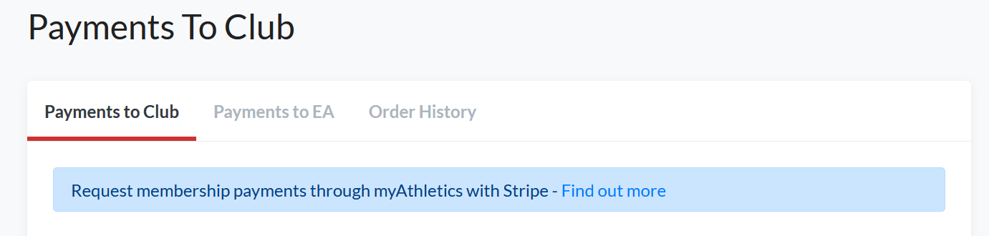

1. You will be taken to the below screen. Enter the full name and email address for the person at your club who you want to be responsible for your Stripe account then click ‘Create.’

**NB. If you are setting the account up on behalf of someone else at your club you will need them to be on hand to verify their email address and mobile number.**

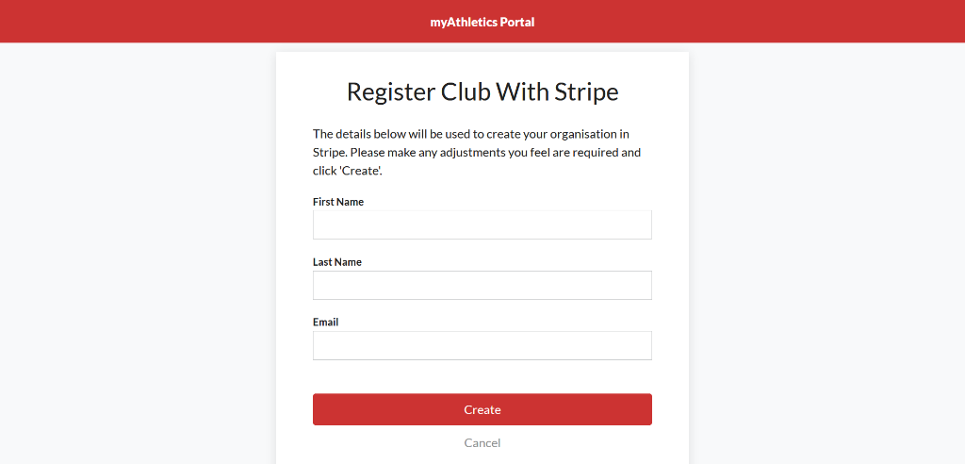

1. This will take you in to the Stripe ‘onboarding’ process as shown below. Enter the same email address again and click ‘Next.’ This should be the email address of the person you want to be responsible for your Stripe account or the email address that is already linked to your club Stripe account if you have one set up already.

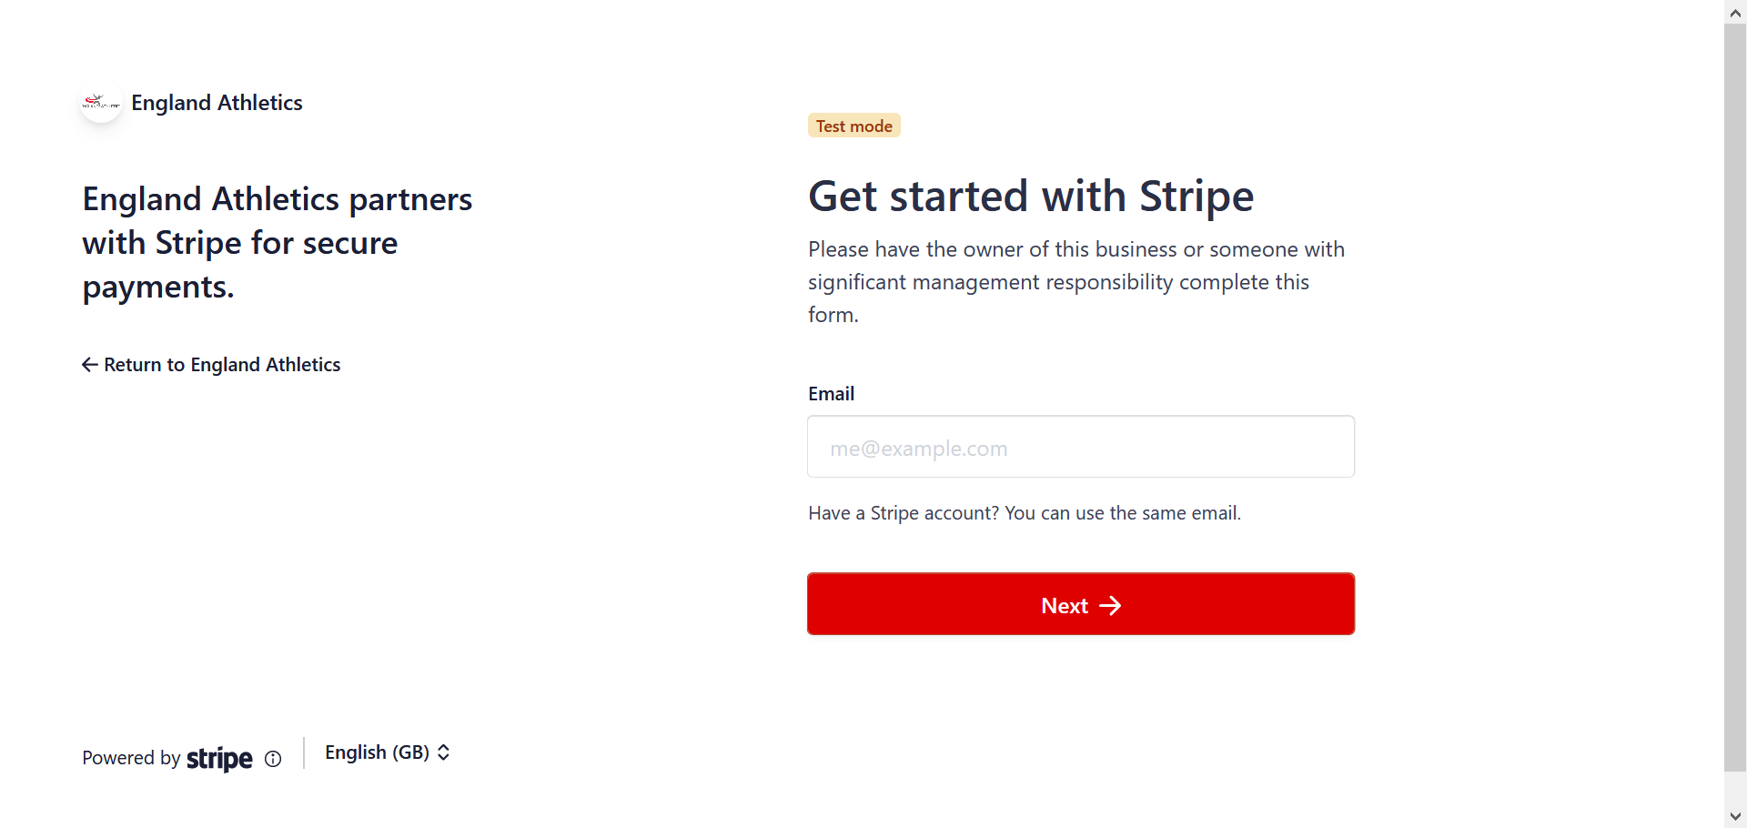

1. On the next screen you will be prompted to create a password for your Stripe account or enter your existing password if you already have an account.

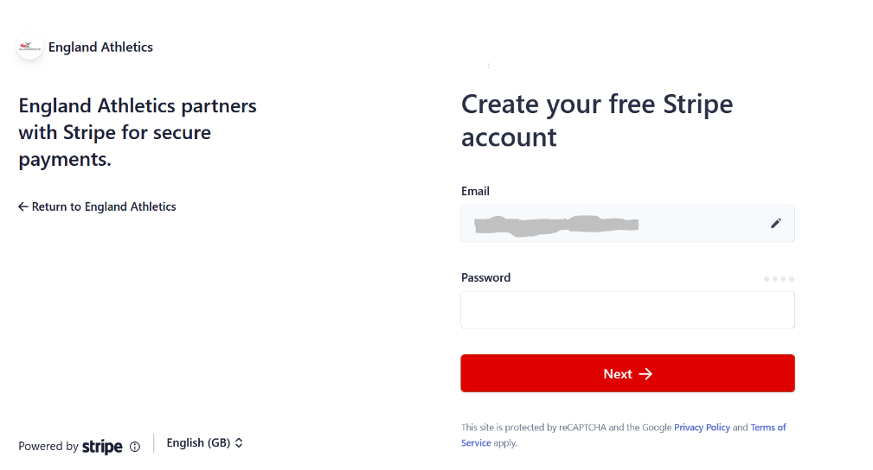

1. Enter a mobile number for your account and then click ‘Send text.’ You will need this to receive secure codes from Stripe to log in to your account in future so make sure you have access to the mobile number that you enter.

If you already have a Stripe account a text will be automatically sent to the mobile number registered on your account and you will just need to enter it as per step 7.

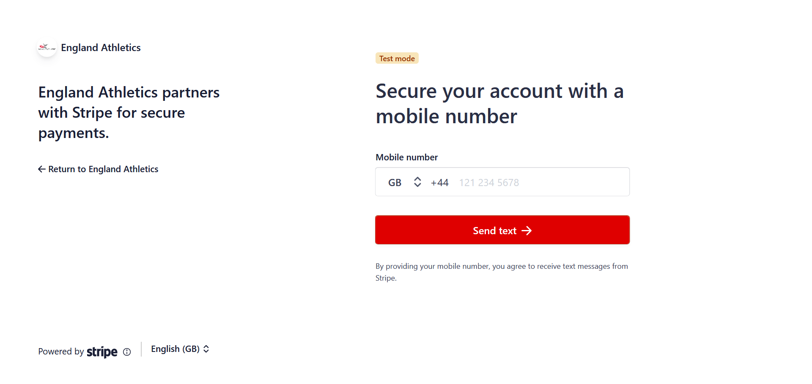

1. Enter the secure code sent from Stripe on the next screen.

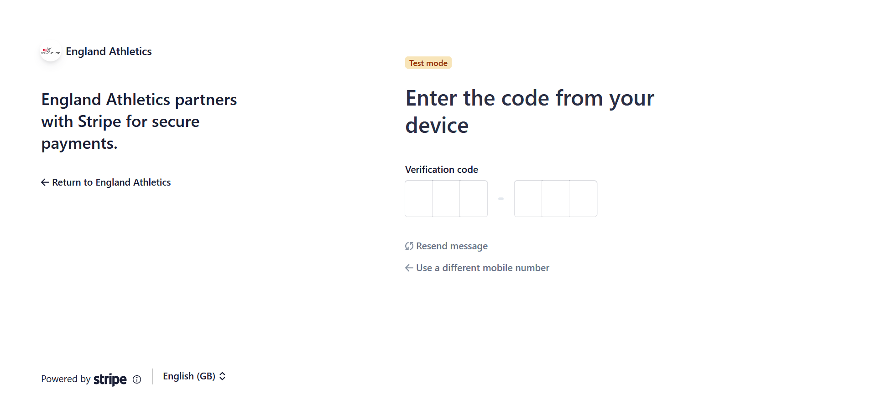

1. If you are setting up a new Stripe account you will be presented with the security code for your account on the next screen, you should make a note of this and keep it somewhere safe for future reference then click ‘Next.’
2. Stripe will ask you to provide some information about your ‘business’ as follows:

* Registered business address – country will default to United Kingdom and then you can enter the business address for your club.
* Type of business - make sure that you choose **‘Individual/Sole Trader.’**

**DO NOT select ‘Non-Profit Organisation’** as this is for formally registered charities and requires extra documentation to be provided to Stripe before the account can be activated.

* Click ‘Next’

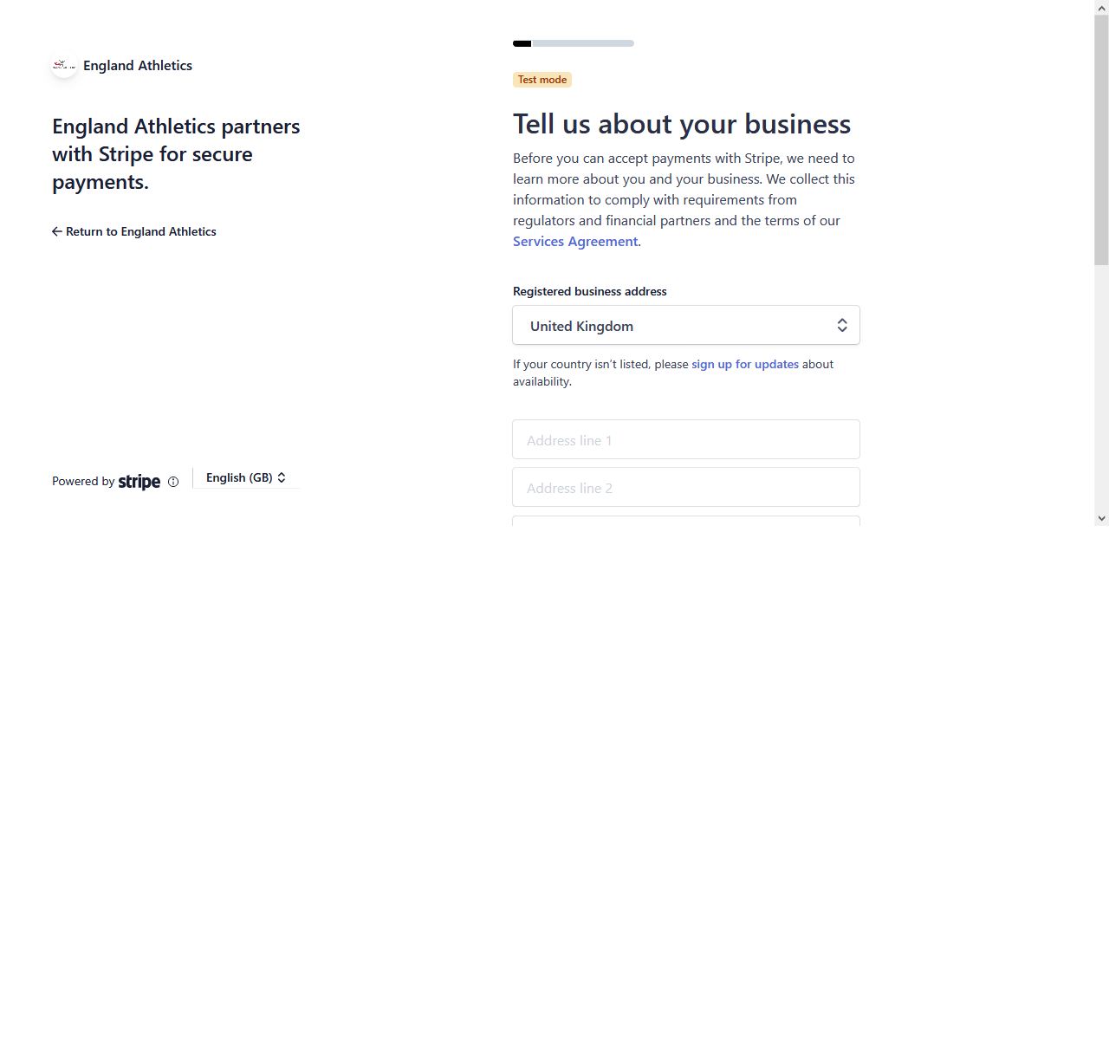

1. Stripe will now ask for your:

Full Name Email address Date of Birth Phone number

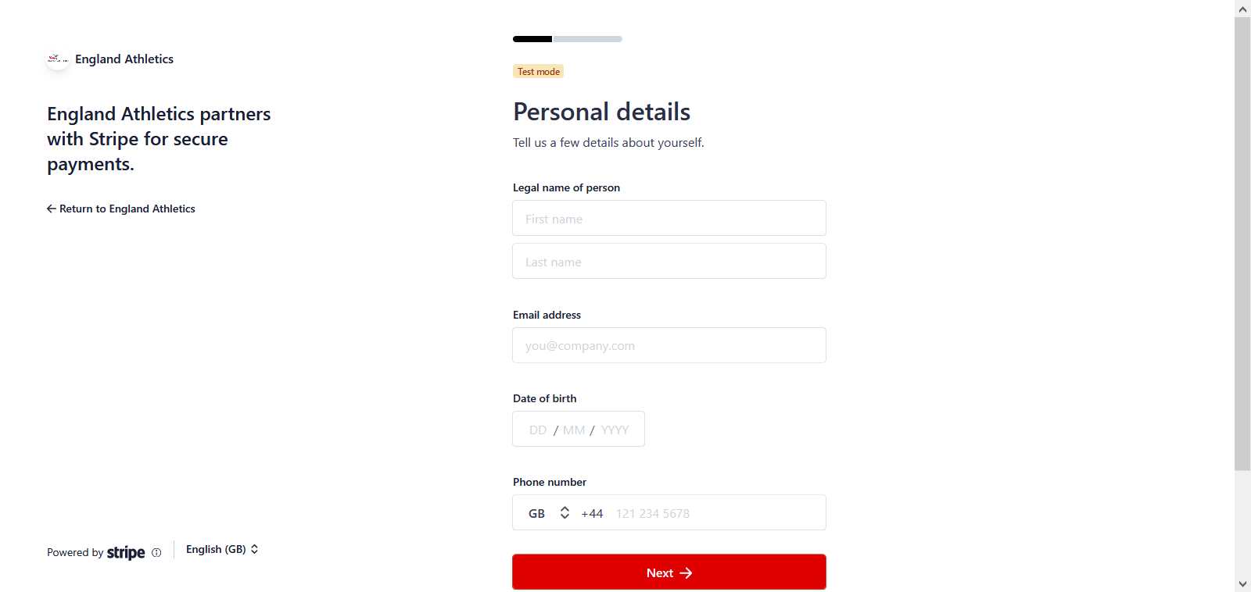

This information is used to conduct their standard anti-money laundering checks and to verify your identity. Click ‘Next’ once you have entered this information.

1. You will then be asked for some further ‘business’ details:

* VAT number – enter if your club is registered for VAT (or leave blank)
* Industry – if you start typing membership in the search you can choose ‘Other membership organisations’ as your business type.
* Business website – enter the website address for your club, if you don’t have one then you can enter a Facebook page or similar, but this field needs to be completed.
* Product description – Type in athletics and running club or something similar that describes your ‘business.’
* Click ‘Next.’

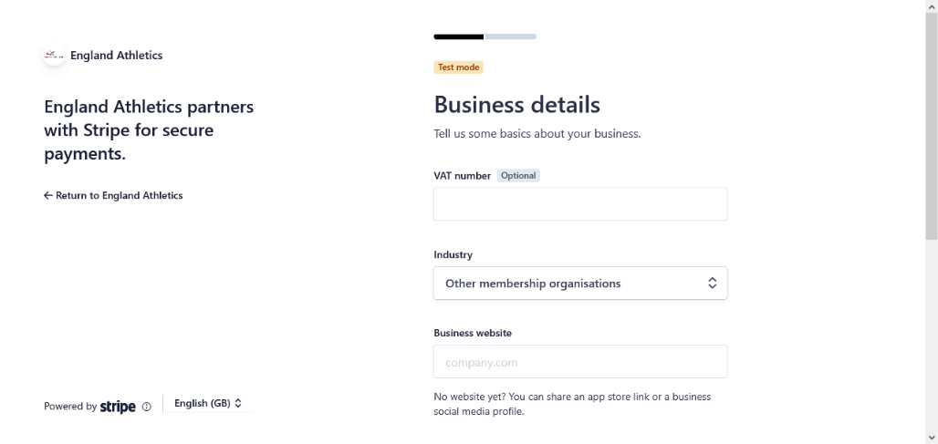

1. Finally, you will be asked for your bank details:

* Currency - make sure that the ‘Currency’ field has defaulted to ‘GBP-British Pound’ or update this to make sure that your payouts are made in Pounds Sterling.
* Country of bank account – this should default to United Kingdom
* You will then be prompted for your sort code and account number, make sure that you enter the details of your club bank account where you want to receive your payouts.
* Click ‘Next.’

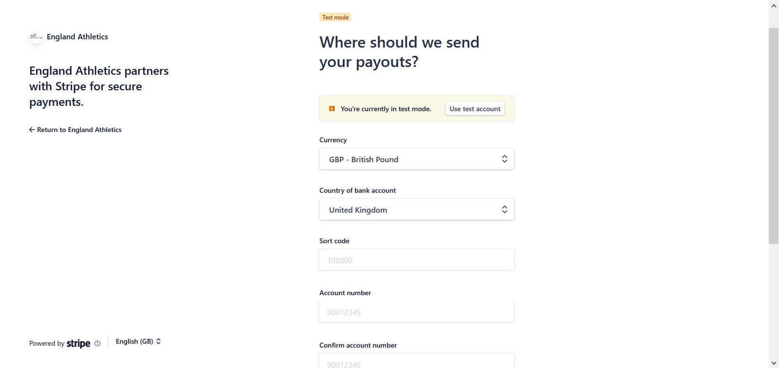

1. Confirm customer statement info – enter the description that your members will see on their receipts and bank account statements once they have made their payments.

* The ‘Statement Descriptor’ should be your club or organisation name. This will default to whatever you entered as your website address, but that is likely to be rejected as too long so you can click the pencil icon to edit this.
* The ‘Shortened Descriptor’ should be a shortened version of your club or organisation name
* ‘Customer support phone number’ is required, this should be the number of a Club Committee member that your members can call should they have any queries on their payments

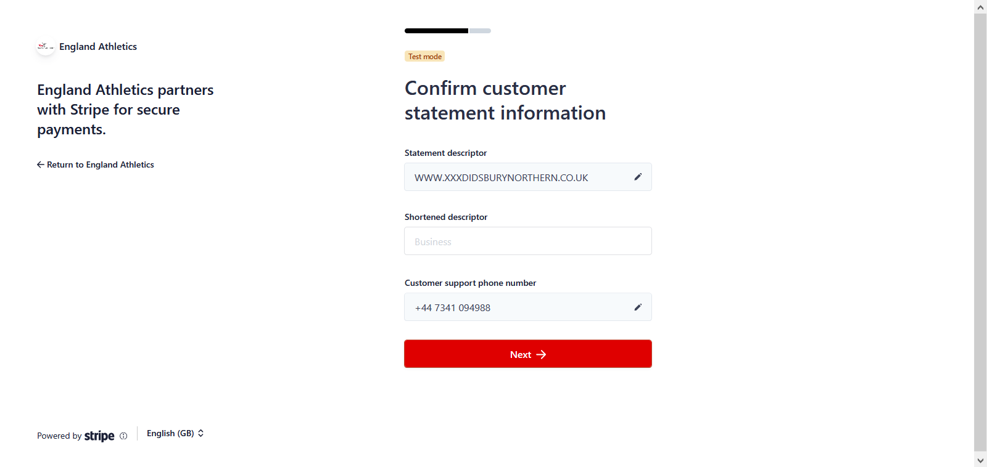

1. After completing this information you will be shown the below summary screen. You can review the information you have provided and make any changes if you have made a mistake. Once you are happy with the information click ‘Done.’

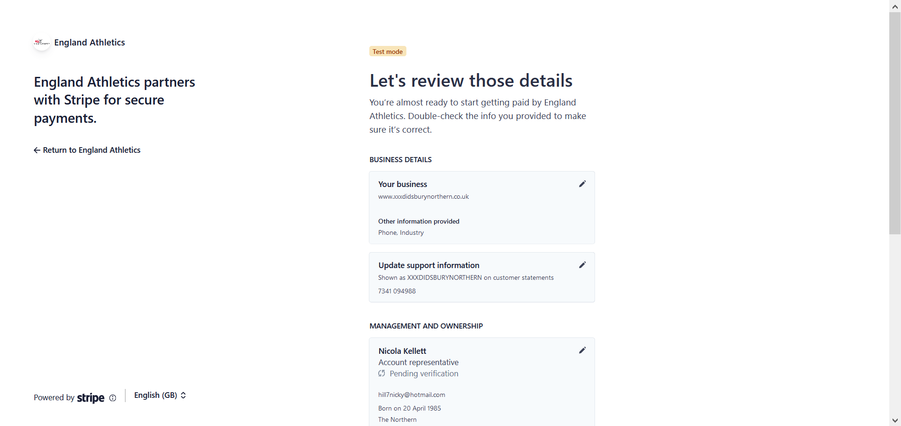

1. You will be returned to the myAthletics portal and you are then set up to start requesting online payments through the portal.

If you have set up a new Stripe account for your club as part of this process you may need to verify your identity with Stripe to ensure that your payouts can be sent to your bank account, you can find out more about how to do this via our Stripe FAQs below.

We would also recommend logging in to your Stripe account once you have set it up so that you can amend the following settings:

* Account name
* Payout schedule
* Branding

For more information on how to update these please see our Stripe FAQs detailed below.

**STRIPE FAQs**

**What do I do if I couldn’t complete the Stripe set up?**

1. If you are unable to complete the Stripe set up process for any reason please go back to the [myAthletics portal](https://myathleticsportal.englandathletics.org/) and click on PAYMENTS on the left hand menu.
2. You will be taken to the ‘Payment to Club’ screen and at the top of the page you will see a blue call-to-action panel prompting you to complete your Stripe sign up. Click on ‘Complete sign up’ to be taken back to Stripe.

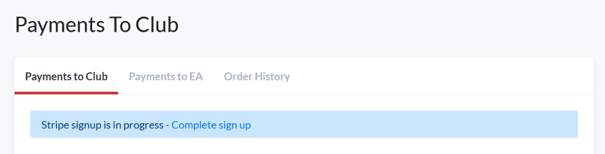

1. You should then be able to complete the onboarding process as per the guide detailed above.

**What if I don’t know the Stripe password for my club?**

If you have previously connected your club to Stripe using our PayZip integration (unlikely for Welsh clubs) then you will have an account set up with Stripe but might not have created a password yet. In this scenario you might see this screen in the setup process:

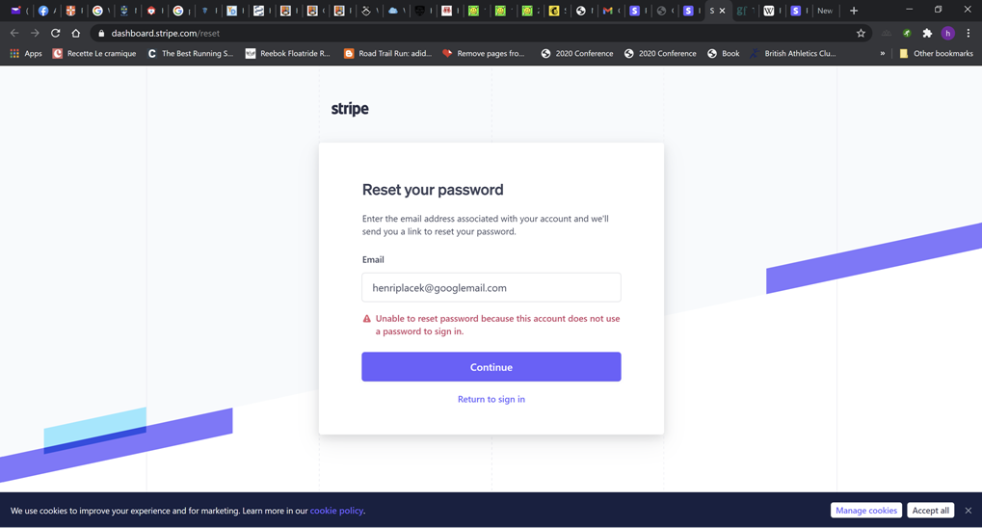

Clicking ‘Continue’ from this page should allow you to continue the setup process as detailed above.

If this doesn’t work please go to: <https://dashboard.stripe.com/login> to create a Stripe password.

You will be prompted to enter the email address associated with your Stripe account and then asked to enter your mobile verification code. If you previously set up a Stripe account through Payzip you will then be given the option to log in to that account or ‘Create a new Stripe account.’ Make sure you click on the option to **‘Create a new Stripe account’** - this will then give you the option to create a password connected to your existing Stripe log in.

Once you have created your password you will be logged in to the main Stripe dashboard, this confirms that your password has been created. You can then log out of Stripe and return to the myAthletics portal to complete the Stripe onboarding process as per this document.

**Why do we have to add a mobile number for account verification?**

Adding a mobile number enables two-step authentication on your Stripe account.

This is a security process which is put in place by Stripe to protect both your user credentials and the sensitive information that is stored within your Stripe account. Two-step authentication adds an additional layer of security to the authentication process by making it harder for attackers to gain access to your Stripe account and is particularly important in the case of Stripe where sensitive information relating to payments is stored.

**Why is my account name defaulting to Welsh Athletics?**

When you first log in to your Stripe account you may notice that in the top left of the screen your account name is defaulting to ‘Welsh Athletics.’ Currently Stripe do not allow clubs to set their account name as part of the onboarding process, but you can edit this once your account has been set up by following these steps:

1. Log in to your Stripe account
2. In the top left-hand corner of the screen you should see the name of your Stripe account which may have defaulted to ‘Welsh Athletics’

NB. If you are using Stripe on multiple platforms for your club you may need to click the drop-down arrow to see your multiple accounts

1. Click the drop-down arrow and then click ‘Edit’ next to the account
2. A pop-up window will appear allowing you to update the name of your account, you should change this to your club name and then click ‘Save.’

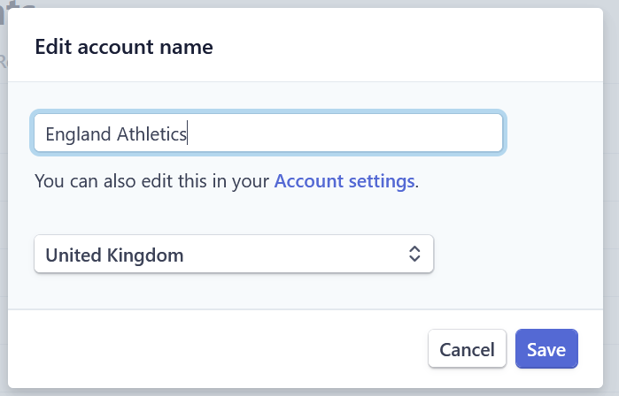

1. You can click on the ‘Account settings’ link to update further information on your account such as the Branding and Payout schedule as detailed below.

**When will my club receive payouts from Stripe?**

When you start processing live payments from your customers with Stripe, you won’t receive your first payout until 7–14 days after receiving your first successful payment. The first payout usually takes a little longer in order to establish the Stripe account and complete Stripe’s ‘Know Your Customer’ checks.

Processing subsequent payouts then happens according to Stripe’s default schedule for UK businesses. This means that payouts will be made daily and contain payments processed seven calendar days prior. For example, payments received on a Tuesday are paid out by the following Tuesday.

We recommend that you log in to your Stripe account and amend your payout setting so that you receive your payouts on a fixed schedule of **weekly** or **monthly** rather than receiving payouts on a daily basis. To amend your payout schedule follow these steps:

1. Log in to your Stripe account
2. Click on Settings on the left-hand menu
3. Scroll down the page to Business Settings and then click on ‘Bank accounts and scheduling’
4. At the bottom of the page you will see the section titled Payout schedule. This will have defaulted to ‘Automatic every day’ but you can use the drop-down list to change this to every week or month.
5. If you choose to receive pay-outs weekly, you can specify the day you would like to receive these and similarly if you choose to receive payouts monthly you can choose the date that your payouts will be received on.
6. Click ‘Save’ to save the changes you have made to your payouts schedule

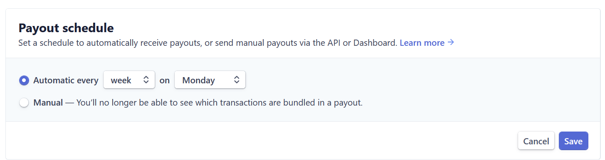

**Will we still receive payment reports through the portal?**

Yes, your club’s payout reports will be available to view and download via the myAthletics portal. To access these:

1. Log in to the myAthletics portal
2. Click on PAYMENTS on the left-hand menu
3. Click on the ‘Stripe Reports’ tab to view your most recent payout reports

The payment reports will be available to download via the portal regardless of the frequency you choose to receive payouts from Stripe, so if you set up your payouts as weekly your reports will be displayed weekly whereas if you set up your payouts to take place monthly your reports will be displayed monthly.

**Why aren’t my club members receiving receipt emails from Stripe?**

Payment receipt emails will be automatically sent from the myAthletics portal whenever your members make a payment online via Stripe.

You can choose to turn on payment receipts to send directly from Stripe in addition to this by turning on ‘Successful payment’ emails through your Stripe account.

1. To change your email settings within Stripe go to <https://dashboard.stripe.com/login>
2. Log in with your Stripe account details
3. Click on ‘Settings’ on the left-hand menu
4. Scroll down the page to ‘Business Settings’ and click on ‘Emails’
5. Under ‘Customer emails’ you can choose to turn on the emails for ‘Successful payments’
6. Click ‘Save’

**How do I change my club’s branding in Stripe?**

You can choose to brand the payments page that your club members are sent to within Stripe and the emails that send to your members via Stripe. This includes adding your club colours and logo. To update your branding:

1. Log in to your Stripe account
2. Click on ‘Settings’ on the left-hand menu
3. Scroll down the page to ‘Business Settings’ and click on ‘Branding’
4. Here you can alter the branding colours and upload your logo
5. Click ‘Save changes’ to make sure your settings are updated

**Need more help?**

If you need more information about how to collect online payments through the myAthletics portal please sign in to the portal and go to the [FAQs](https://myathleticsportal.englandathletics.org/Home/Faqs) area. There is lots of guidance in this area to help you with using the new portal and collecting online payments for your club.

If you still have questions about using the myAthletics portal please email [office@welshathletics.org](mailto:office@welshathletics.org) and one of the team will be in touch to help.